**Programs Offered**

* Robotics/Tinkering
* Computer Hardware
* Mobile Repairing
* Cooking/Hospitality
* Beauty/Wellness
* Stitching & Cutting
* Electrical Troubleshooting
* Two-Wheeler Repairing
* Mobile Journalism
* Computer Science
* Call Center/BPO
* Logistics
* Data Digitization
* Natural Farming Market Connect
* Banking

hhhhhh

ww

**Literacy India Community College (LICC)**

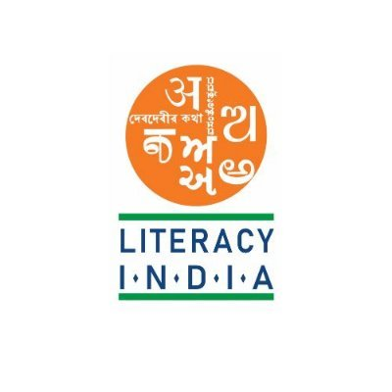

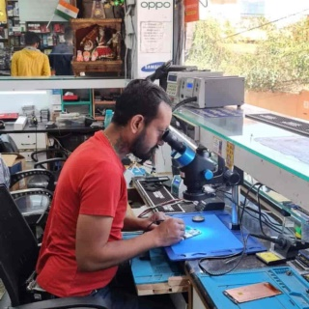

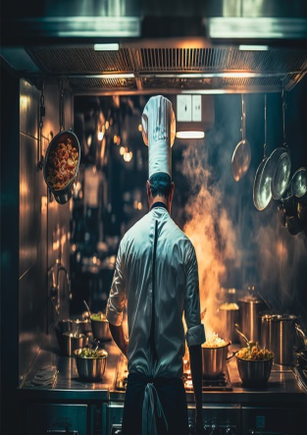

[**www.literacyindia.org**](http://www.literacyindia.org)

Session Starts From

January 2024

**Contact no- 8588853380**



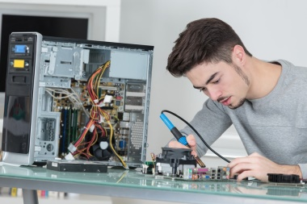

**Register Now**